**Array Cardio Day 2**

We got two arrays. One with people and one with comments.

.some will check if at least one thing in your array meets what you are looking for

const isAdult **=** people.some(function() {

Some will take a function that will check it for every single one that we have

const isAdult **=** people.some(function(person) {

const currentYear **=** (**new** Date()).getFullYear();

**if**(currentYear **-** person.year **>=** 19) {

**return** true;

*//above cleaned up*

const isAdult **=** people.some(person => ((**new** Date())

.getFullYear()) **-** person.year **>=** 19);

**console**.log({isAdult});

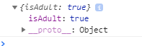

Next is for all which is pretty much the same

const allAdults **=** people.every(person => ((**new** Date())

.getFullYear()) **-** person.year **>=** 19);

**console**.log({allAdult});

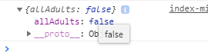

Next we have find which is a lot like filter but instead of returning a subset of the array its going to return you the first item that it finds

const comment **=** comments.find(function(comment) {

**if** (comment.**id** **===** 823423) {

**return** true;

}

});

**console**.log(comment);

*//above cleaned up*

const comment **=** comments.find(comment => comment.**id** **===** 823423);

**console**.log(comment);

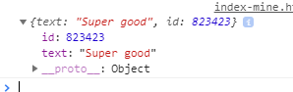

Finally we have .findindex which is going to find where something is in the array

const index **=** comments.findIndex(comment => comment.**id** **===** 823423);

**console**.log(index);



Now to delete it you could do it like this

comments.splice(index, 1);

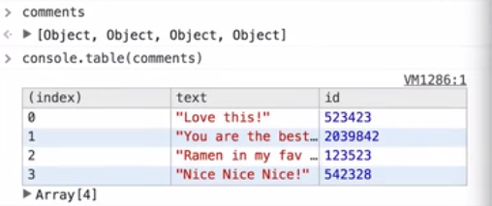we see that the Super good is removed

Or now popular in the redux world we can just create a new array of the updated comments

const newComments **=**[

**...**comments.slice(0, index),

**...**comments.slice(index **+** 1)

];

(… is spreading the contents into the new array)

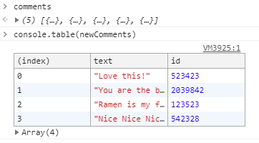

THAT’S IT!